THE BEGINNING

The Metropolitan Transit Development Board (MTDB), created by State law (Mills, SB 101) in 1975, was empowered to design, engineer, and build fixed- guide way facilities within San Diego County. San Diego Trolley, Incorporated (SDTI) was created by the MTDB in August, 1980 as a wholly-owned subsidiary responsible for operation and maintenance of the LRT system.

SDTI currently operates three light rail transit lines, referred to as the "Blue Line", "Orange Line" and "Green Line".

PATRONAGE
Patronage has grown steadily from 10,000 to 14,000 daily passengers during the initial phase of revenue service to 103,000+ passengers on an average weekday in 2005. During special events such as football, baseball and other public events, ridership varies between 110,000 and 200,000 passengers.

FIXED FACILITIES
San Diego Trolley's LRT system encompasses an area of just over fifty-two and six tenths (52.6) double track miles in length, nineteen and one tenth miles (19.1) miles on the Blue Line, twenty-and six-tenths (20.6) miles on the Orange Line and nineteen and one tenth (19.1) miles on the Green Line. The fixed facilities are identified as two LRV Maintenance Facilities & Storage Yards, Facility building and one yard tower "A yard". The facility building includes office and work areas for Facilities, Revenue, and Stores Departments.

TRACTION POWER/SUBSTATIONS
SDTI trains are electrically propelled using high voltage DC power (700V) distributed from traction power substations located along the right-of-way that feed the overhead catenary system (OCS). Isolated sections of the OCS can be de-energized by opening appropriate circuit breakers in the substations and/or pole mounted sectionalizing switches. SDTI utilizes fifty four
- substation locations throughout the system that are equipped with an external beacon flashing trouble light that can be observed and reported by passing trains.

LIGHT RAIL VEHICLES
SDTI currently has a fleet of 134 Light Rail Vehicles (LRVs) manufactured by the Siemens Corporation. All LRVs are articulated at the center with an operating cab at each end. There is no access between the cars when they are coupled together. Each LRV seats 64 passengers with a design capacity crush load rated at 200 passengers. Safety features include a fire extinguisher mounted in every operating cab, a mobile radio equipped with a silent alarm button mounted in each operating cab, and a fail-safe system to prevent movement of the train in the event doors are not fully closed. Trains are controlled manually by an Operator who performs all operational functions.

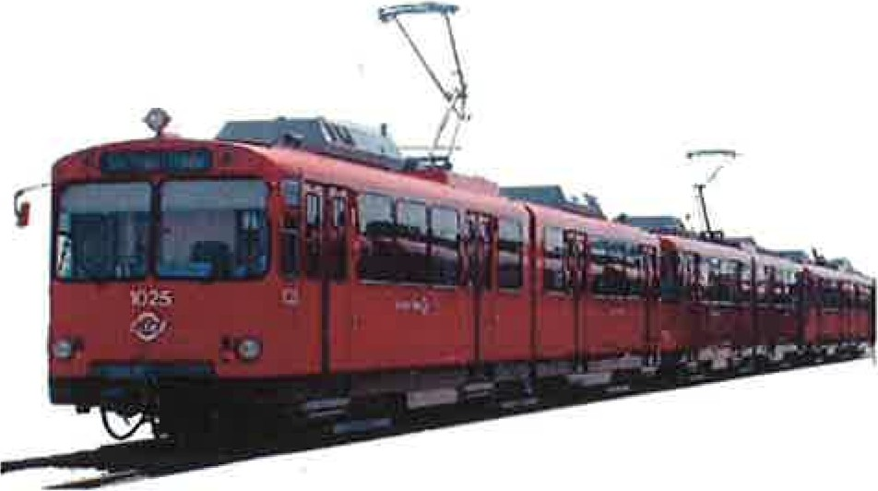U2 LRV
Manufactured by Siemens-Duewag, Dusseldorf, Germany and Sacramento, California
Five Orders: 1980-1989
Vehicles: 71 Length: 80 feet

Weight: 40 tons

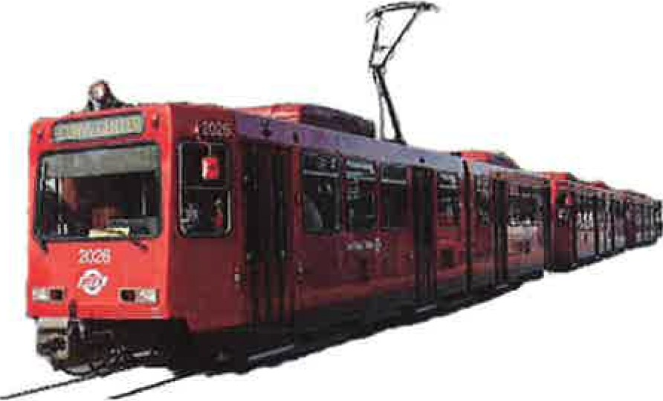SD-100 LRV
Max Speed: SO mph

Manufactured by Siemens, Sacramento, California One order: 1994-199S
Vehicles: S2 Length: 80 feet

Weight: 40 tons
Max Speed: SS mph

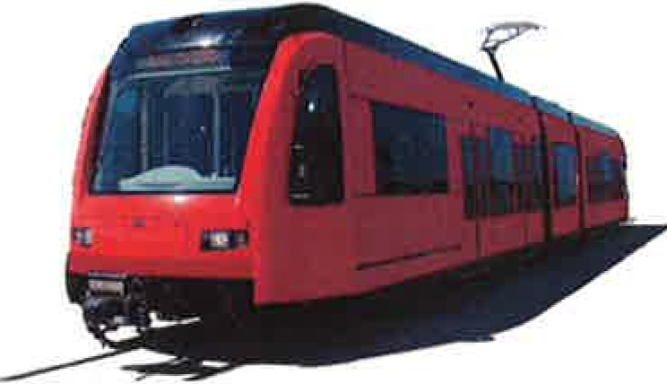S70 LRV-S70 ULTRA SHORTS
Manufactured by Siemens, Sacramento, California Length: 90 feet US:80 feet
Weight: 48 tons Max Speed: SS mph

OPERATIONS CONTROL CENTER (OCC) SUPERVISOR 619.595.4960

SAN DIEGO VINTAGE TROLLEY PRESIDENTIAL CONFERENCE CAR 529

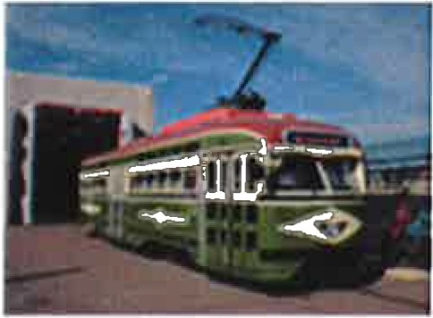

Length 45 feet Weight 25 tons Maximum Speed 25 mph

The San Diego Metropolitan Transit System Vintage Trolley is a historic PCC streetcar operation utilizing

San Diego downtown track alignment. The line segment runs clockwise from the 121
h
and Imperial

Transit Center along the Bayside, C Street and Park Boulevard Corridors. The Silver Line will augment regular trolley service during limited mid-day hours on weekends, unless an additional schedule is requested for special events and/or charter groups.

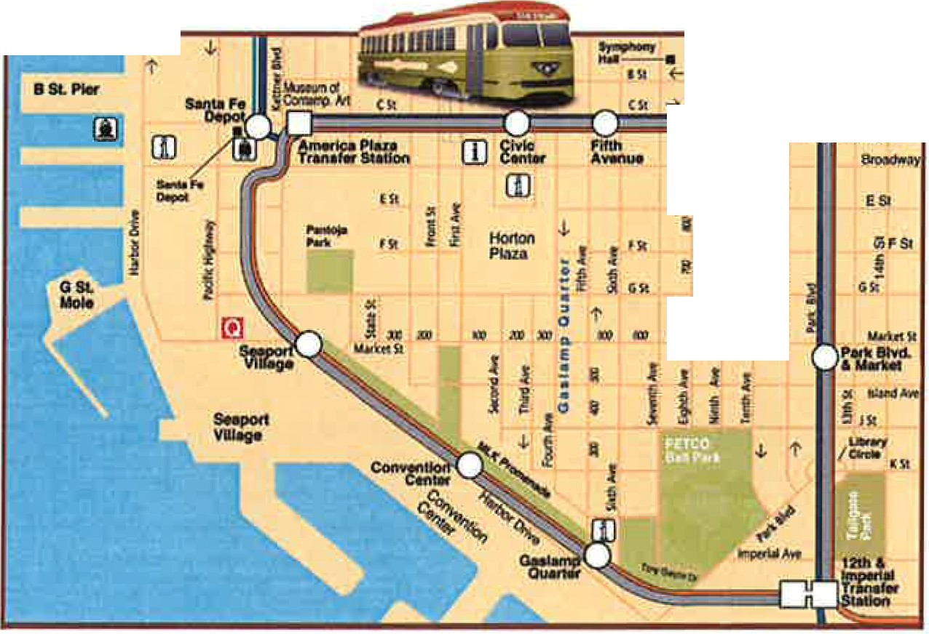:CCCJ::::::::::::::;::::z::J::::=::::c::c:::::;:::::::::::::::c c
l
t ,j. 1'

.I
/tl)t .. .. l

- PCC Sllvw Une service
- Trolley Blue Un• service
- Trolley Orange Une service

The following subjects will be discussed during the familiarization on vehicle 529:

  - Lifting points and undercarriage of car

  - Emergency exits

  - Fire extinguishers

  - Radio/Contact information

  - Pantograph Control

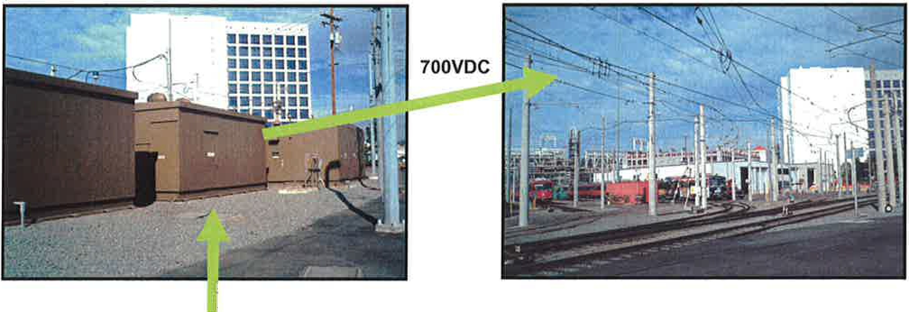
12,000VAC SDG&E

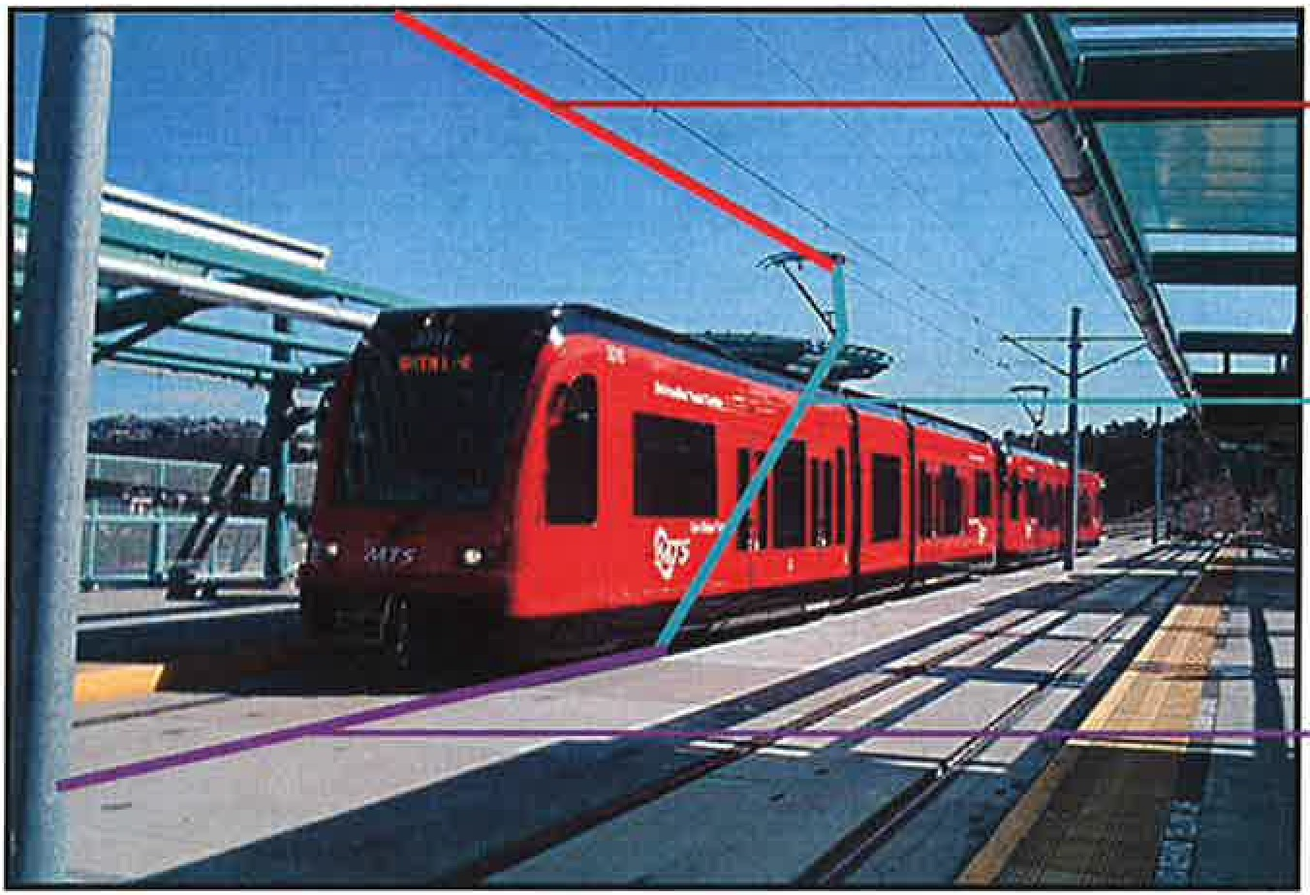
Electricity travels through catenary to LRV
Then travels through pantograph to provide
power to LRV
Then returns to the substation (negative)

From Electrical Hazards Awareness, EFCOG Electrical Safety Improvement Project, page 9

STEP POTENTIAL

During a ground fault, current flows through the grounding system to a ground rod or some type of system ground (steel structure, guy wire) seeking a return to its source. This current flow could possibly exist in, or along the surface of the ground for quite some distance around the point where the earth becomes energized. The current will follow, as nearly as possible, the conductors supplying the fault current. Step potential is caused by the flow of fault current through the earth. The closer a person is to the ground rod or grounded device, the greater the concentration of current and the higher the voltage. The current flow creates a voltage drop as it flows through the earth's surface and a person standing with their feet apart bridges a
portion of this drop thus creating a parallel path for current flow as seen in the these two illustrations in Figure 3.

FIGURE 3 STEP POTENTIAL

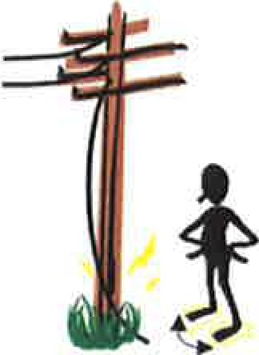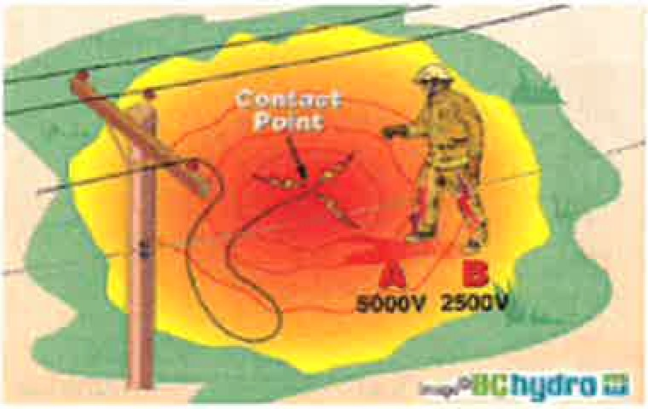

The wider apart a person's legs are, the larger the voltage difference across the body. Protection from the step potential hazard should be to stay in the zone of equipotential while working. Simply being alert to this hazard is the best defense. For this reason, unqualified personnel standing on the ground are cautioned to stay clear of structures.

This means that a person standing near the point where fault current enters the earth may
have a large potential difference from foot-to-foot. The potential difference over the same span will be less and less as the span is moved away from either the fault current entry point or the fault current return point at the source.

OUTSIDE

Traction power wire - catenary/direct suspension.
Negative return Catenary Wire Down Pantograph
Electrical Safety
Gaining entrance to a deactivated car Entering LRV on non-platform side Blind spots

MAIN LINE DANGERS

On the right of way during bi-directional traffic operations
Powered switches

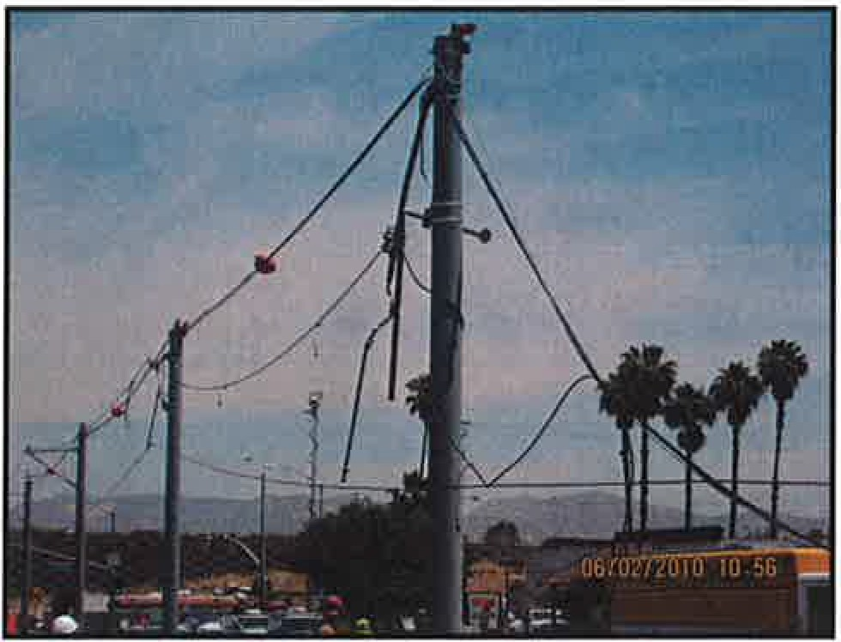

INSIDE

Entering Train Operator Cab Console buttons
Pantograph DOWN Battery OFF Interior lights
General overview of cab layout
Radio communications to OCC utilizing cab radio

DOORS

Emergency latches Mechanics of door
Opening the door while the train is in motion

);>- Do not assume the railroad has stopped other train traffic!
);>- Confirm with your dispatcher that the Operations Control Center has been notified of your presence.
);>- Make contact with the incident trains Operator or the Trolley's incident-response personnel at the scene.
);>- If you are the first responder Trolley will be on scene as quickly as possible.
);>- What is most important before you put yourself or your equipment near the tracks?
);>- What you should expect about the hazards at the incident scene?
);>- Communication with OCC or a Trolley representative. 619.595.4975

AGAINST CURRENT OF TRAFFIC LRV
The operation of trains on double track against the Light Rail Vehicle normal current of traffic, without ABS protection.

CONTACT WIRE MAIN TRACK
An overhead wire from which power is collected by the A track extending through yards and between stations, train. the use of which is governed by the authority of the
Controller and signal indication.

CONTROLLER OPERATIONS CONTROL CENTER (OCC)
The designated employee on duty in Central Control The designated location from which all SDTI having authority over all movements on or affecting operations are authorized and directed.
SDTI tracks.

CURRENT OF TRAFFIC PANTOGRAPH
On double track, the current of traffic is to the right A device on top of a Light Rail Vehicle to collect power unless otherwise ordered by the Controller or by from the contact wire.
written instructions.

DOUBLE TRACK REGULAR TRAIN

Two main tracks, on one of which the current of traffic is in a specified direction, and on the other in the opposite direction.
A train designated by timetable.

DUAL CONTROL SWITCH REVERSE TRAFFIC

A power operated switch controlled automatically by the approach of a train or by a route selector. It is also equipped for manual operation.
ABS protected operation of trains on main track other than the normal current of traffic.

EXTRA TRAIN TRAIN

A train not designated by timetable, such as a freight train or other on-track vehicle.
One or more Light Rail Vehicles or engines displaying a headlight to the front and a taillight to the rear.

HAND SIGNAL YARD TRACK

A signal given by the motion or position of a person's hand, arm, flag, or light.
All tracks used for car storage, repair, or other purposes.

RUNNING RAILS
Rails comprising the track upon which a train moves.

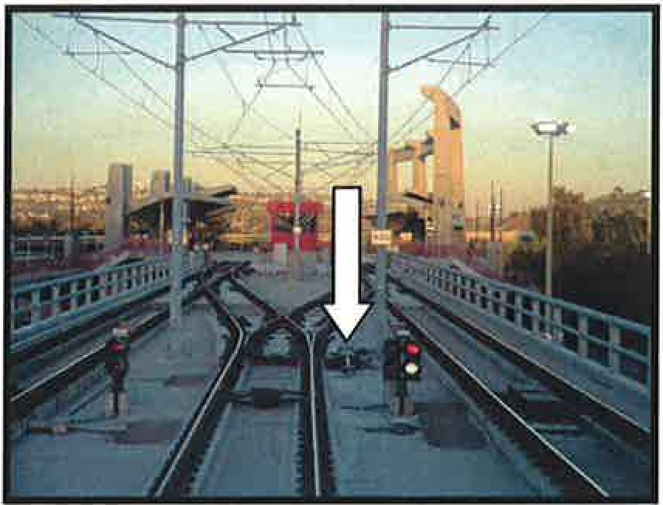

RIGHT:

Red emergency latch pull down to open door in emergency from the inside of the car.

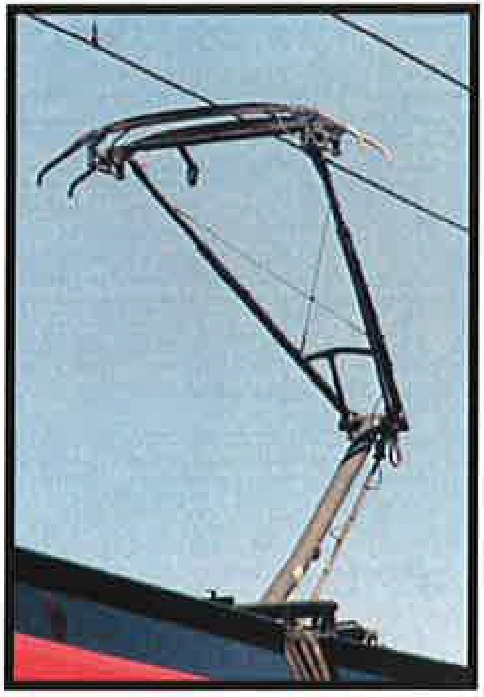

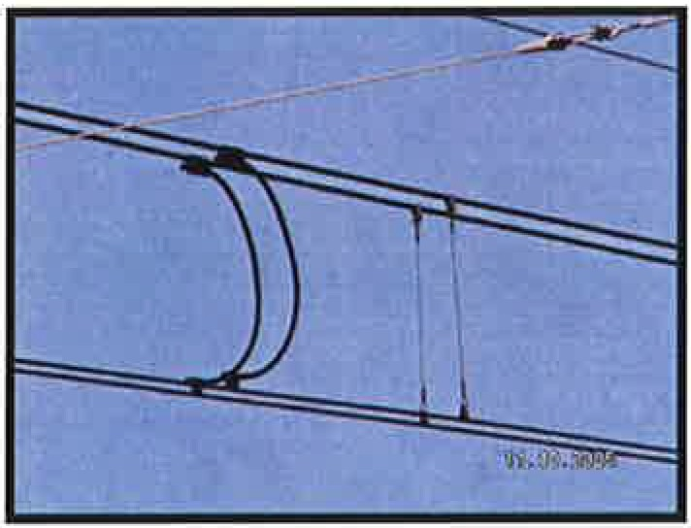RIGHT:

Overhead Catenary System. Always assume all wires are energized follow basic electrical safety procedures when the wire is down. The wire varies in current and can reach up to (and exceed) 700 volts of direct current (DC) power.

LEFT:
Powered Switches may be requested by trains over a mile away and can move without a train in sight. It is important to stay clear from switch points at all times. Getting a foot caught in the point would cause major injury or death depending on the track speed of the train on approach and/or the sight distance of the operator.

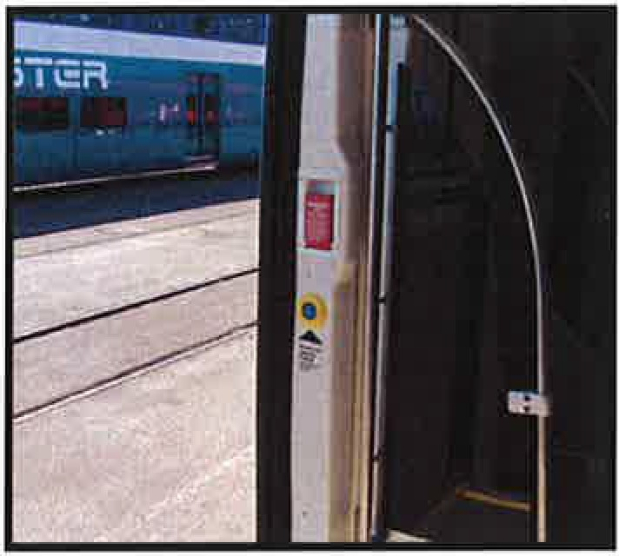

LEFT:
Pantograph and catenary wire.

