Usage:
Used to remove victims in technical rescue situations.

Specifications:
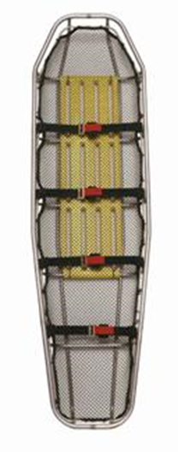
- ASTM Grade 2 Titanium
  - Unalloyed titanium
  - TIG Welded
- Dimensions: 83”x 23”x7.25”
- Weight: 13.5 Lbs.
- Rating: 2,500Lbs
- Double walled head and foot ends
- 1” Tope tube
- Durathene netting won’t corrode, breathes, and won’t snag
- Polyethylene back support
- Fits standard backboard
- Main frame, ribs, skids, inserts
- Solid and Break-down models available

operations:
- Remove from apparatus with backboard
- Attach to rescue system
- Lower with/to rescuer to secure victim
- Lash the patient into basket
- Haul patient and rescuers to safety

maintenance:
- Inspect for cracks, bends and dents that could affect strength
- Inspect netting and back support

