Usage:
Typically used in a confined space environment. Allows users to work in IDLH by providing 10-minute Emergency Escape Cylinder to use if the supply air (via umbilical line) is compromised.

Specifications:
- Air cylinder: 15cubic feet, 3000 psig, 10 minutes of air
- Mask Mounted Regulator (MMR)
- Shoulder harness, waist strap & cylinder assembly

safety:
- The Emergency Escape Cylinder should be turned off during normal use, and only in a true emergency would you want to use the air contained in the cylinder
- Test the mask seal and function of the apparatus outside of the IDLH before entering.
- Confirm cylinder has full supply of air.

operation:
- Umbilical air supply lines can be connected up to a maximum of 300’ with a max of 5 quick-connect couplings. (HM/R 17 has 100’ hose lines)
- Umbilical air supply line requires an inlet pressure of 60-100 psig.
- Connect umbilical air supply line to the “Main” port

maintenance:
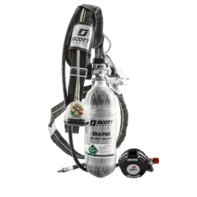
- Wipe down harness and cylinder after each use.
- If the apparatus is soiled, use a sponge damp with mild soap and/or soft brush to remove dirt, etc.
- Let air dry out of direct sunlight.

