Usage:
Used as a forcible entry tool to ram, pry, cut, break locks and create openings.

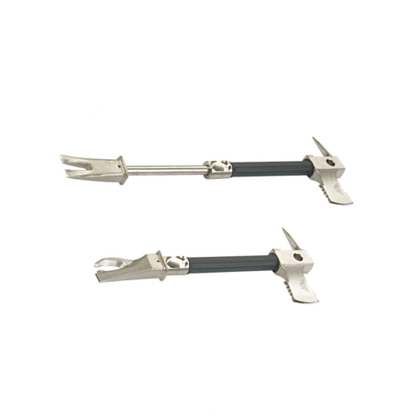
Specifications:
Pry Axe
- Heat treated alloy steel
- Chrome plated for easy maintenance
- Steel shaft with press fitted and pinned to the claw
- Rubber sleeve handle
- Weight: 6.6Lbs
- Length: 18”& 28”(extended)
- Pick and Fork
- Serrated Axe
- Optional Metal Cutting Claw

operations:
To Extend:
  - Push the release button or the release lever and extend
To Separate:
  - Extend the fork to the stop and turn 180o pull and separate
  - 90o prying capabilities
Ram:
  - Extend and hold below the shaft with one hand and on the grip with the other and slide to ram.

maintenance:
- Check welds/pins for cracks and separation
- Check for bends
- File to sharpen and remove burs
- Oil shaft

