# **Usage:**

The Amerex 240 pressurized water extinguisher is used for Class A fires only. It operates by compressed air expelling water to cool the fire.

# **Specifications:**

Amerex 240 PW

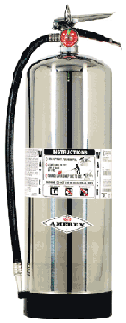Construction: Drawn Stainless Steel Construction

Capacity: 21/2 Gallons

Filled to 100psi

Pressure Tested to 300psi

Rated: 2A

3/8” Rubber Hose

Rated to 250psi

Weight: 27Lbs

Discharge Time: 50sec.

Discharge Distance: 45’-55’

Temps: 40o-120o

Warranty: 6 years

Hydrostatically tested every 5 years

# **operations:**

Remove from apparatus

Hold upright

Use PASS to extinguish the fire

Back away facing the fire to put out any re-ignition

# **maintenance:**

Inspect at least monthly

Inspect can, hose, and gauge

* Look for cracks
* Leaks
* Drop in PSI
* Wearing and abrasions

Clean any dirt and debris

Recharge after use or when needed