Usage:
NAPA Safety Triangle Kit includes three safety triangles and one convenient carry box. The box is complete with instructions on the inside of the lid.

Specifications:
Safety Triangles
- Plastic construction
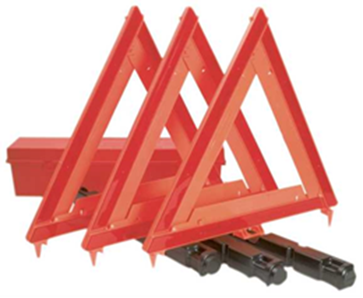
- Sand filled base
- Withstands strong winds
- Dimensions: 17¾” High X 16 5/8”Wide
- Meets FMVSS 125
- Federal Motor Vehicle Safety Standards
- Devices without self-contained energy
- Unfolds and locks together
- Instructions on each side of the triangle
- Orange Plastic carry box
- Placement instructions inside lid

operations:
- Remove Orange Box from apparatus
- Open and remove triangles
- Set up the triangles in accordance to situation and diagrams
- When complete, pick up triangles and replace in box

maintenance:
- Make sure triangles are operable and not missing pieces
- Ensure that kit is complete and in correct location in apparatus

