Federal Fire Department San Diego Training
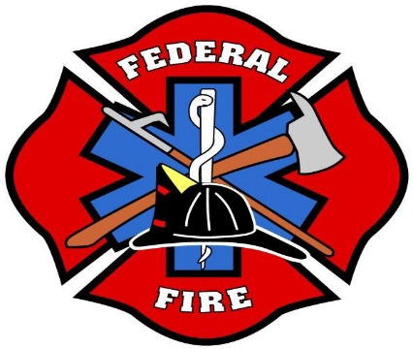

Low Angle Rope Rescue Training Drill Focus Sheet

The following are some LARRO chapters and focus points/pages specific to the chapter that will help direct personnel down the path of success for the drill.

Chapter 4 Focus on: Double Loop Lark's Foot
Three Bight: Single Loop, Double Loop and Multi Loop

Chapter 5 Focus on: Pages 66-68

Chapter 6 Focus on: Pages 71-75

Chapter 7
Focus on 3&4 rescuer attachment.
How to accomplish a 3&4 rescuer attachment if there is not a pre-rig available Chapter 8
Chapter 9

Chapter 10 Focus on:
How to weeve an Eight Plate and a Brake Bar Rack

