Usage:
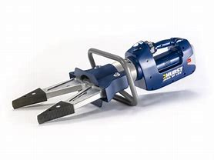The Hurst Jaws of Life Spreader is used mainly for auto extrication in spreading and pinching the vehicle to remove the vehicle from the patient.

Specifications:
Hurst 300E Spreader
- Max. Spreading Force: 25,000lbs. @ back of tips
- Max Pulling Force: 6,295lbs.
- Max Pulling Distance:19.5”
- Max. Opening: 24”
- Weight: 45.2 lbs

operations:
- Push ON/OFF Button
- Use Deadman switch to open and close cutter
- After use leave Spreader slightly open and shut off
- Wipe down and inspect for damage

maintenance:
- Remove dirt and debris by wiping down
- Use WD-40 to lubricate fittings

