Usage:
Provides positive and negative pressure ventilation to confined spaces. Additional applications include Manhole Entry System, Cooling, and Heating Systems

Specifications:
- Intrinsically safe
- 3 horsepower
- 19lbs
- DUCTING 15’ x 8”
- FREE AIR – 980 cfm
- 90degree bend – 789 cfm
- 90degree bend – 666 cfm

safety:
- Do not operate if there is any damage to cord, plug or receptacle.
- Be aware of surroundings.
- Use ground connector when operating in potentially hazardous atmosphere.

operations:
- Proper PPE
- Ensure the switch is in off position prior to starting
- Ensure the airflow indicator is pointed the right way
- Place ducting in area needed
- Minimize bends in ducting if possible
- Turn on RAMFAN

maintenance:
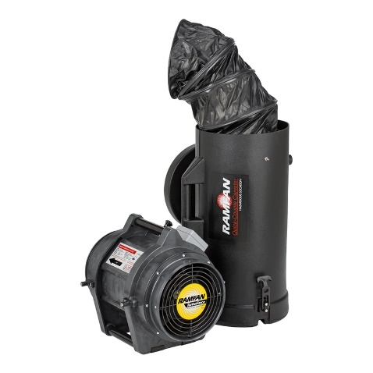
- Ensure there is no damage to the RAMFAN and power cord
- Wipe down
- Make sure there is no debris in ducting

