Usage:
Capable of reducing the lifting/pulling line force by 75%.

Specifications:
- Hardware: 11,800 lbs MBS
- Rope: 10,341lbs MBS @ 150’

operation:

Application

- Piggy back on existing line with prussic loop
- Pull in-line with system
- Disengage gain-saver cam while stretching pulleys to length
- Use gain-saver cam while hauling

key points:
- Apply directly to anchor and load, or piggyback on existing line w/ prussic loop.
- Pull in-line with system
- Disengage gain-saver cam while stretching pulleys to length
- Use gain-saver cam while hauling

maintenance:
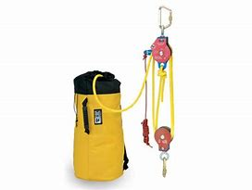
- Clean and inspect after each use

