Federal Fire Department
Shipboard Fire
Company Training Drill # 3

Shipboard Firefighting Training Drill

Critical Safety Points:
NFPA Standard:  1005/1403/1405 | Terminal Objective:  Extinguish a class B fire in machinery space | Dept. Sop # :  176
Equipment Required: Three (3) Engine/ Truck Companies, Two (2) Chief Officers |  | Apparatus or Specific Equipment:
Member Instructions:
Instructor / Operators Instructions: (See RTC Shipboard SOP for position descriptions)
Ensure All Instructors / Operators have drill specific CDO / DCA turn over information. See Shipboard Training Information Sheet

Pre Drill Structure Layout
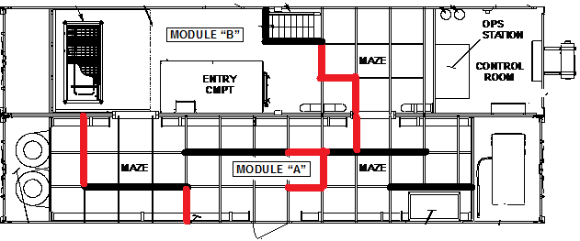
Task Step |  | Drill # 1 | Drill # 2 | Drill # 3
Size Up
1. | Command Duty officer Calls FFD when fire is detected
2. | First in Engine will respond to the vessels quarterdeck access in investigating mode
3. | Remaining apparatus will stage at the pier access gate / or on the quay wall (primary staging) awaiting assignment
4. | First in FFD company officer will meet ship's CDO or DCA at the Quarterdeck to determine the vessels assistance needed and acquire the information needed to provide that assistance
5. | See size up work sheet on Page 4
Strategy And Tactics
6. | First in FFD company officer will establish or pass Incident Command depending on the personnel on scene.
7. | Facilitate Unified command by radio communication with the DCA or by having a FFD officer (Operations) in the DCC (Damage Control Central)
8. | IC will call for additional resources as needed (optional)
9. | IC will determine the plan of action based on the ship’s assistance required and will assign command positions (See Task Sheet 11)
Implementation
10. | IC/OP’s remain in communication with ships DCA or delegate for unified command. (See Assignment work sheet 13 for First alarm assignment requirement’s)
11. | 1st alarm crews equipment brought aboard will consist of Full PPE, Spare SCBA bottles, TIC, Rope Bag, 2 hose packs, Light box, and accountability tags.
12. | IC briefs hose deployment crew on loading location, and length needed to reach point of entry
13. | IC briefs attack crews and RIT on communication method, location of fire, class of fire, progress by ship’s crew, hazards involved or in a exposed compartment
14. | Crew reports to point of entry
15. | IC request a ship crew member to guide first attack crew to location
16. | Crew reports to point of entry in ready standby mode. RIT crew brings RIT pack along with normal equipment
17. | Accountability reports to the point of entry. Accountability SOG in use. Keep track of a 15 minute IDLH time.
18. | Pump operator will position engine according to hose deployment location. Pump operator is responsible for his water supply

Task Step |  | Drill # 1 | Drill # 2 | Drill # 3
Firefighting Operations
19. | Attack teams are in proper PPE
20. | Attack teams test for proper agent prior to entry
21. | Proper tactics are used to access watertight IDLH environment
22 | Attack teams work as a team to transverse through ship operating from an elevated deck and operating down.
23. | Attack teams move hose through passage ways to 3rd deck and extinguish class B in machinery space fire with proper hose streams
24. | Company officers report status of fire to operations and in turn reports status to IC. Attack teams withdraw.

Task Step 5 | Shipboard Training Information Sheet
Information given to First In Officer:
- Location of fire, compartment(s), deck(s), uses, and exposures
- What class(s) of fire.
- What measures have been done to combat the fire, systems activated?
- How many personnel are available on the vessel to combat the incident?
- Have non-essential personnel been evacuated from vessel.
- Obtain damage control plates (Firefighting Plans) from USN.
- Communications.
- Hazards involved

Task Step 9 | Shipboard Training Information Sheet
Information given to IC from First In Officer:
- Location of fire, compartment(s), deck(s), uses, and exposures
- What class(s) of fire.
- What measures have been done to combat the fire, systems activated?
- How many personnel are available on the vessel to combat the incident?
- Have non-essential personnel been evacuated from vessel.
- Obtain damage control plates (Firefighting Plans) from USN.
- Communications.
- Hazards involved

Task Step 11 | Shipboard Training Information Sheet
Information given to Hose deployment Crew Attack Teams & RIT:
- Plan of Action will determine Point of entry
- Hose needed
- Location to position pumping engine for hose deployment

Task Step 13 | Shipboard Training Information Sheet
First Alarm Assignments:
- IC – 1st Company officer until relieved by Battalion Chief and will then assume Op’s
- OP’s - 1st Company officer until relieved second staff officer
- Hose deployment crew – 3 person crew including crew leader
- Attack – 3 person crew including crew leader
- RIT – 3 person crew including crew leader
- Pump operator
- Accountability

